Date: 23/12/2020
Your Ref: Localism
Our Ref: ECS/SC/LOCAL21
Enquiries to Section: StreetCare Design & Operations
Tel: 01454863696

Ref: Localism 2021

Your current contract is due for renewal from April 2021 in evaluating our current cost base we have identified that the contracted annual uplifts using CPI have not kept pace with our operational costs since inception in 2014.

During this period 2014 up to 2020, we have chosen not to re-evaluate our costs instead concentrating on providing you with cost effective services. Now after seven years we have started the process of baselining our current service delivery costs to understand the size of this gap.

It was our intention to have carried this out during 2020 as most contracts come to a natural end in March 2021. Unfortunately, the onset of the Coronavirus pandemic delayed this process so at this time, we feel it would be unfair to renegotiation any increased costs for 2021 as we are aware that many parish and Town Councils have already made budget decisions.

We are proposing for the period April 2021 up to March 2022 to extend your current contract in line with CPIH currently 0.7% as of September 2020.

Below is an illustration of your costs for 2021/22.

FEATURE TYPE | UNITS | MEASURE | Total
AMENITY GRASS | M2 | 13,783.15 | £3,124.02
255 Park Lane Frampton Cotterell | M2 | 274.00 | £39.45
SHRUB BED - MULCHED | M2 | 248.50 | £274.91
LITTER BINS (PARISH OWNED) | NUM | 1 | £250.49
DOG BINS (Standard Once per week) | NUM | 16 | £2,404.68
Crossbow Recreational Field Dog Bins twice per week |  | 4 | £1,246.26
Crossbow Recreational Field Litter Bins twice per week | NUM | 8 | £2,492.53
Centenary Field Litter Bins- twice per week | NUM | 3 | £934.70
Centenary Field Dog Bins -twice per week | NUM | 3 | £934.70
Riding Road Dog Bins- twice per week | NUM | 2 | £623.13
Beesmore Road Litter Bins- once per week | NUM | 6 | £939.04
Beesmore Road Dog waste Bins -Once per week | NUM | 4 | £626.03
Beesmore Road paly Area Litter Bin -once per week | NUM | 1 | £156.51
 |  | TOTAL | £12,906.84

Our intention is to put a new offer together during 2021 and provide this to you ahead of any 2022 budget decisions.

We hope this is acceptable and hope to continue to provide a cost-effective service into the future but please do not hesitate to contact me or one of my team if you have any questions.

Yours sincerely

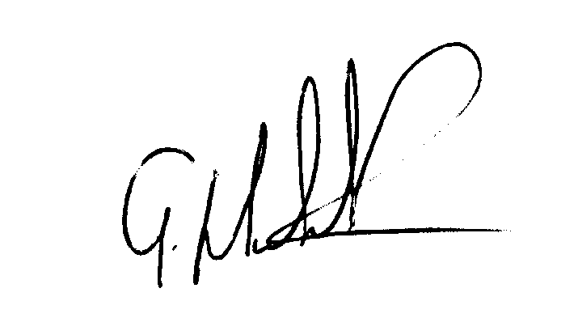

Gary Meddick

StreetCare Operations Manager

